Seizure detection(jupyter)

[1]I implemented two Notebooks the first one is without feature engineering and the second one is with feature engineering.

[2]Link first notebook: <https://www.kaggle.com/code/suchitravelusamy/epileptic-seizure-detection>

[3]Link second notebook :

<https://github.com/Mr-Jree/Epileptic-Seizure-Binary-Classification/blob/master/Seizure%20Binary%20Classfication%20Notebook.ipynb>

# [4] Dataset:

<https://archive.ics.uci.edu/ml/datasets/Epileptic+Seizure+Recognition>

The dataset is available on UCI's machine learning repository here. The dataset includes 4097 electroencephalogram (EEG) readings per patient over 23.5 seconds, with 500 patients in total. The 4097 data points were then divided equally into 23 chunks per patient, each chunk is translated into one row in the dataset. Each and every row contains 178 readings, that are turned into columns; in other words, there are 178 columns that make up one second of EEG readings. All in all, there are 11,500 rows and 179 columns with the last column containing the status of the patient, whether the patient is having a seizure or not.

OR

Download it from here :

<https://www.kaggle.com/code/suchitravelusamy/epileptic-seizure-detection/data>

* First notebook (without feature engineering) ->

[5]modify on line of code and add some part of code :

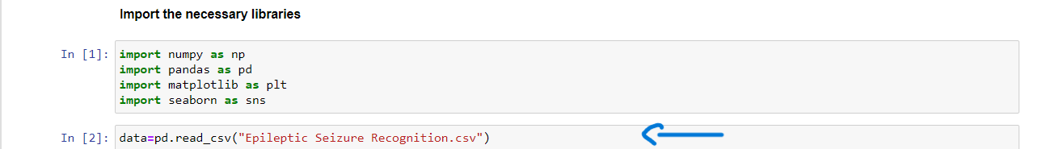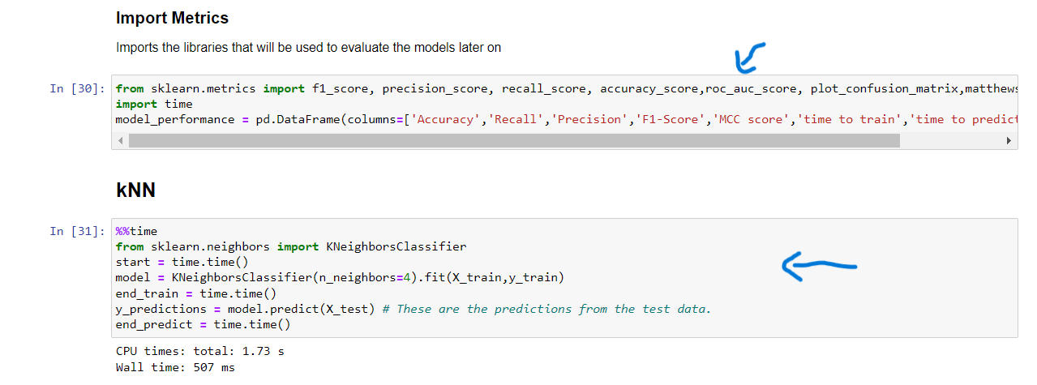

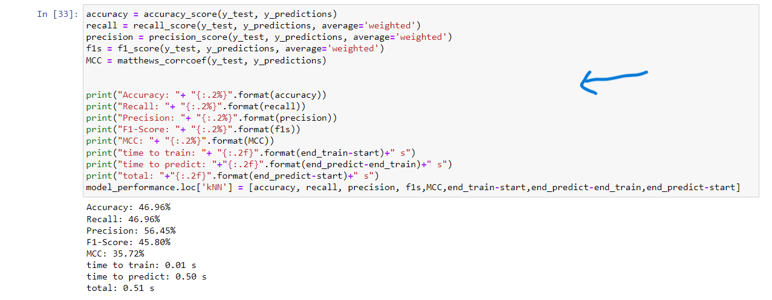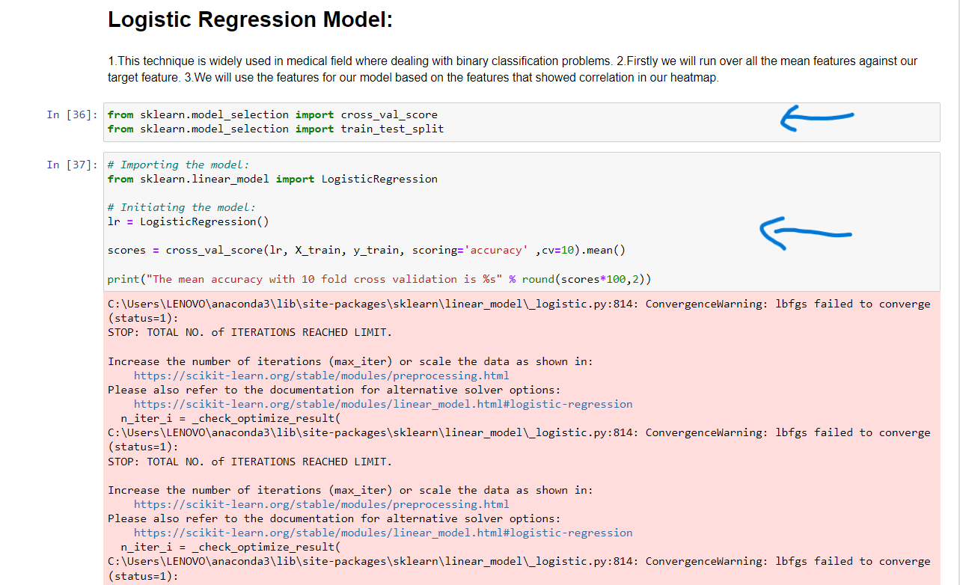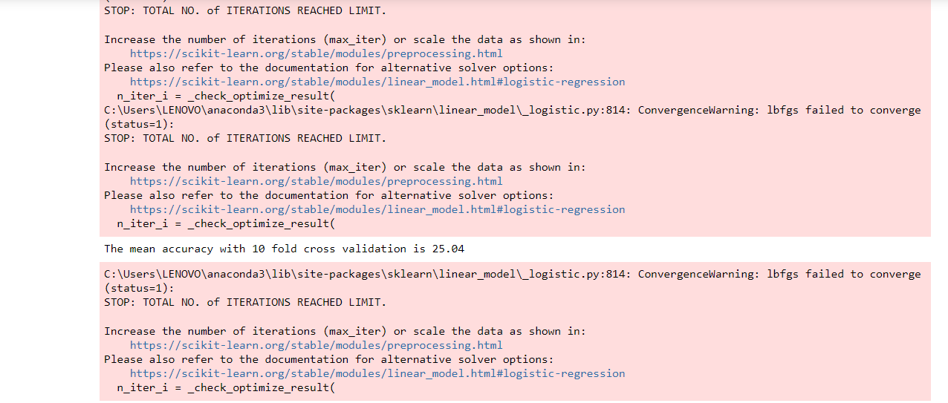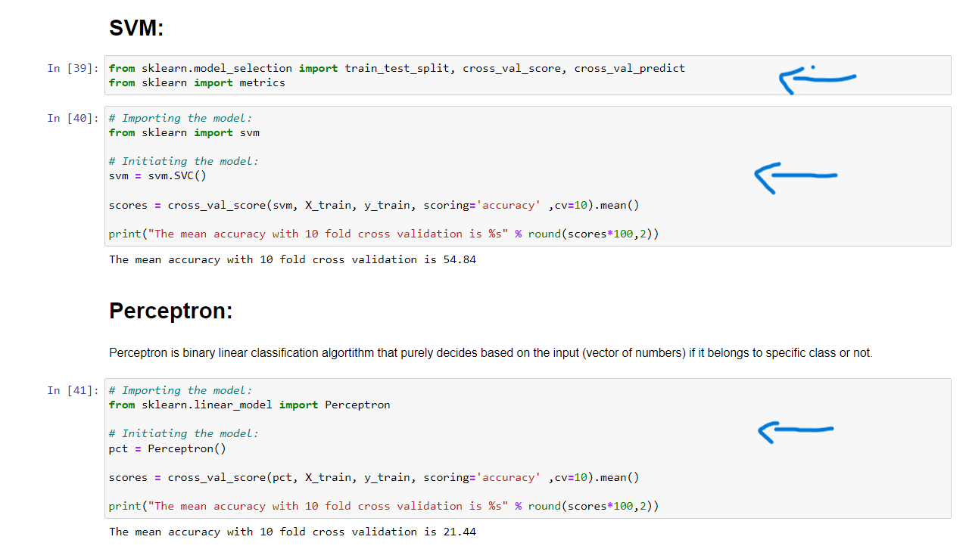

[6] Import the necessary libraries :

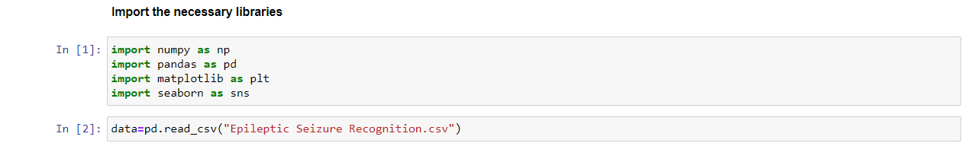

[7]Read the Dataset :

[8] **Exploratory Data Analysis :**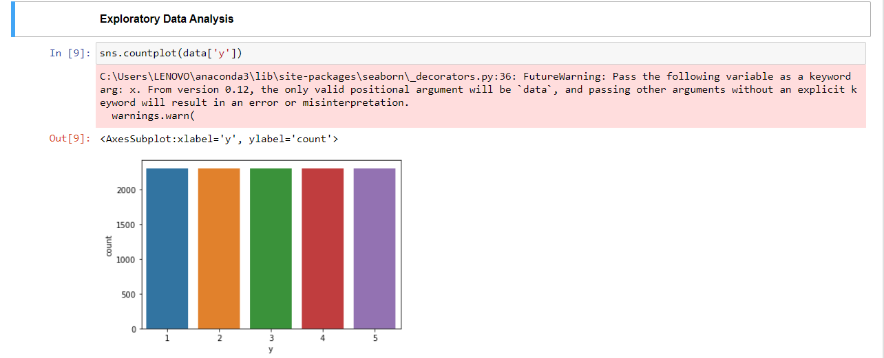

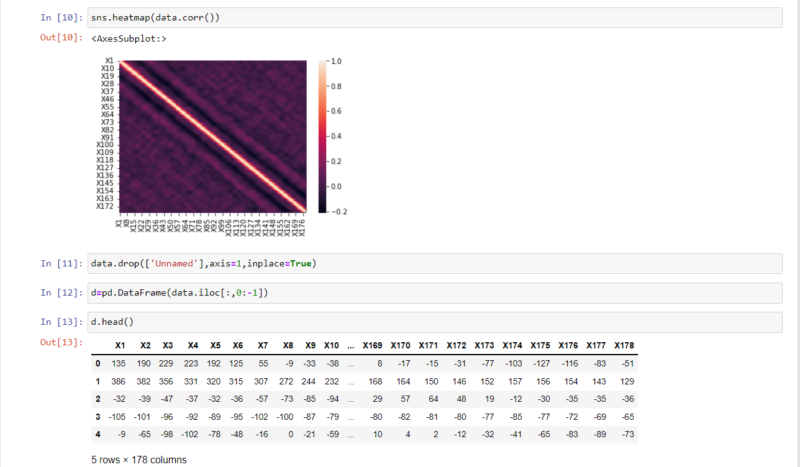

[9] Standardize the data:

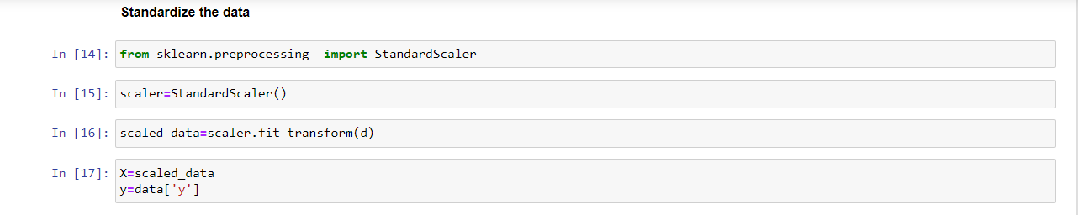

[10] Split the data into train/test:

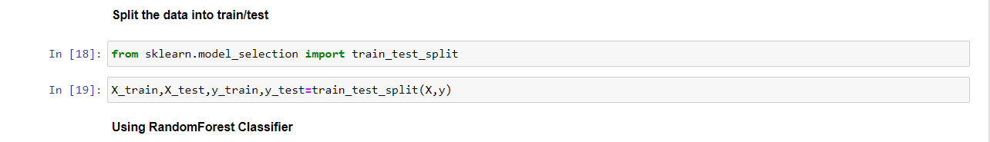

[11]Accuracy :

|  |  |  |  |  |  |  |
| --- | --- | --- | --- | --- | --- | --- |
| models | Random Forest | kNN | Logistic Regression | SVM | Perceptron | Naive Bayes |
| acc | 0.68 | 46.96 | 25.04 | 54.84 | 21.44 | 0.43965213 |

* Second notebook (with feature engineering) ->

[12]Install all the necessary packages :

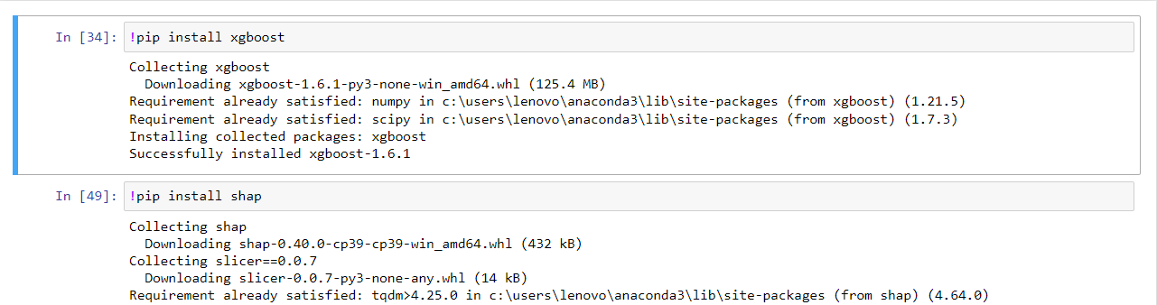

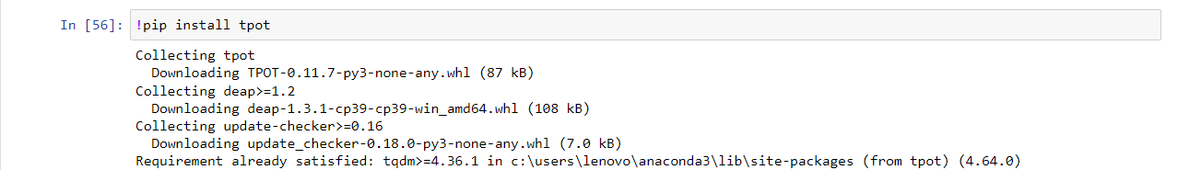

* I Delete some codes that it dose not work.

[13] Introduction :

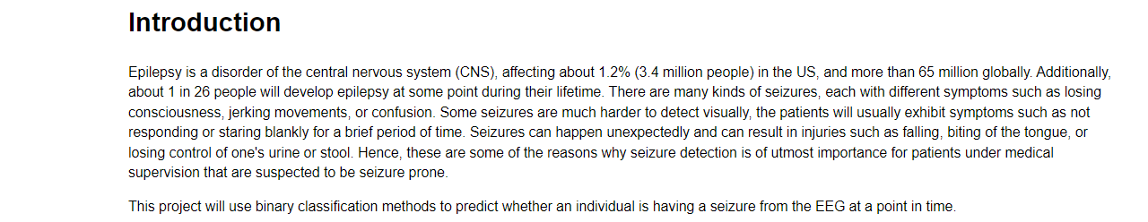

[14] Project Definition:



[15] Data Exploration:

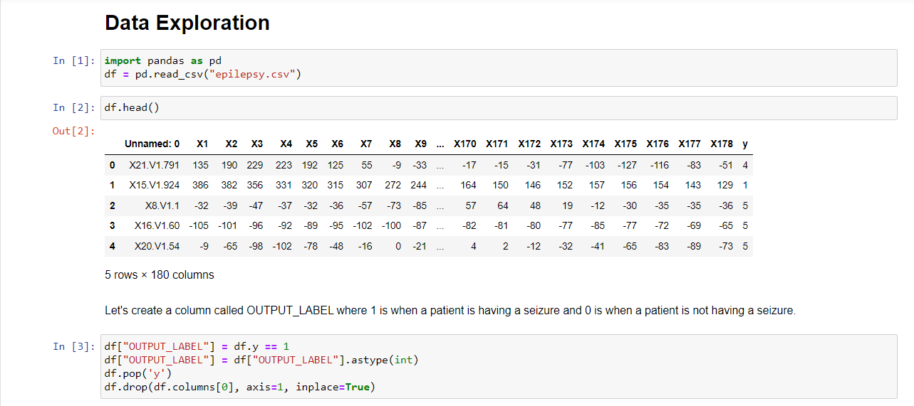

[16] Feature Engineering:

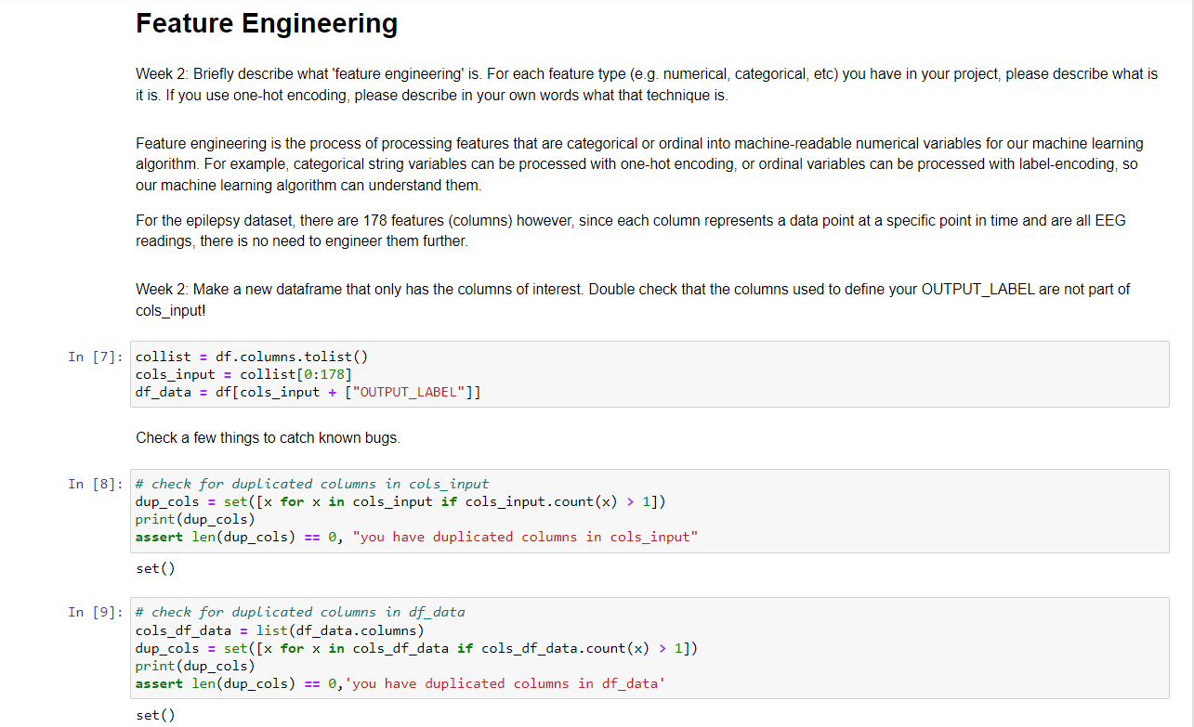

[17] Building Training/Validation/Test Samples:

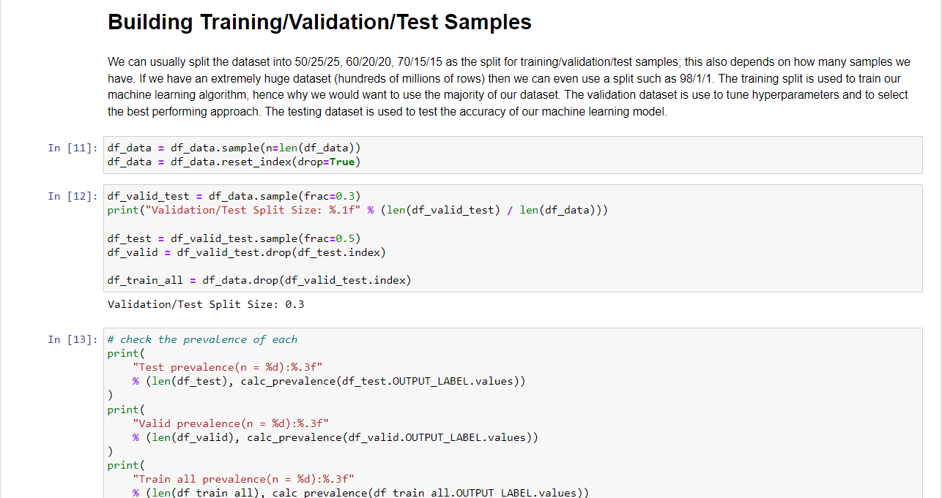

[18] Model Selection:

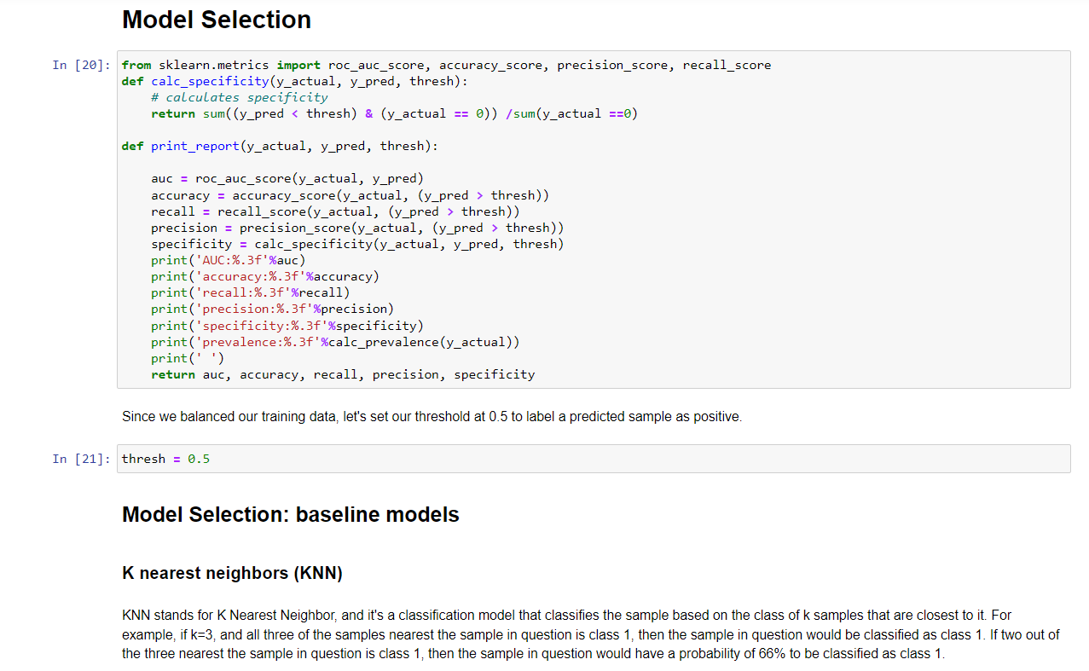

[19] Analyze results baseline models:

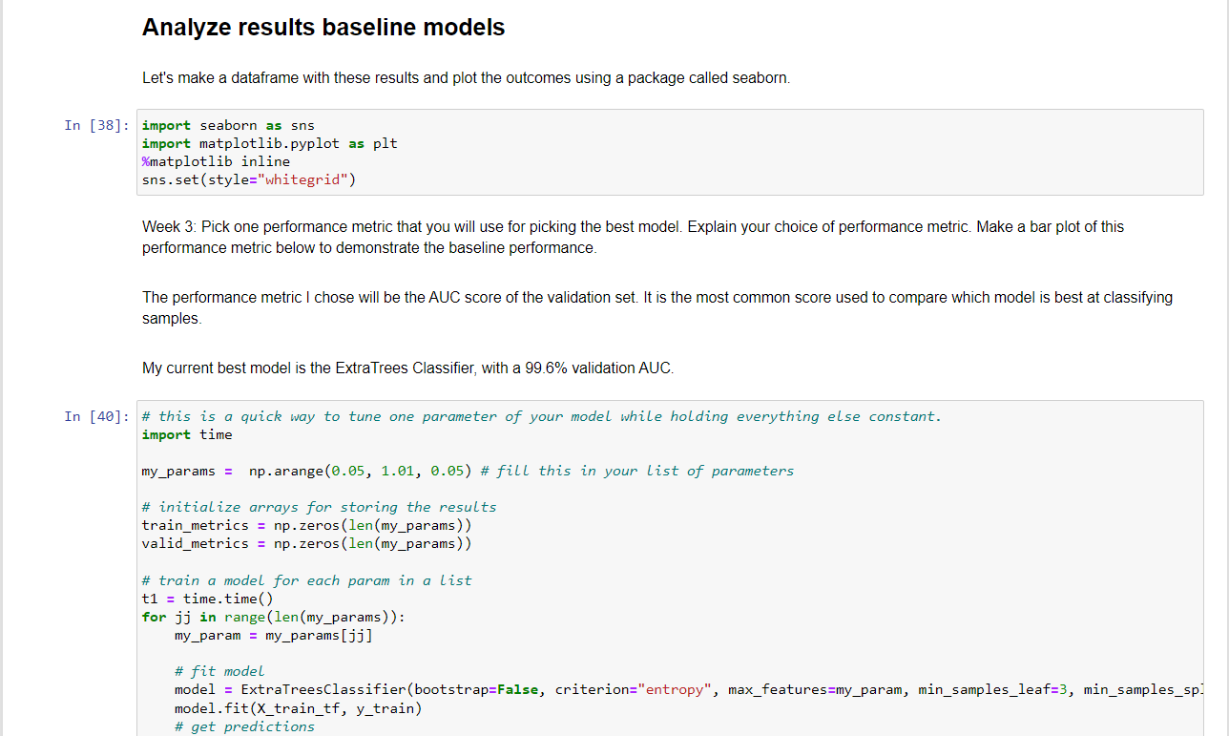

[20] Learning Curves:

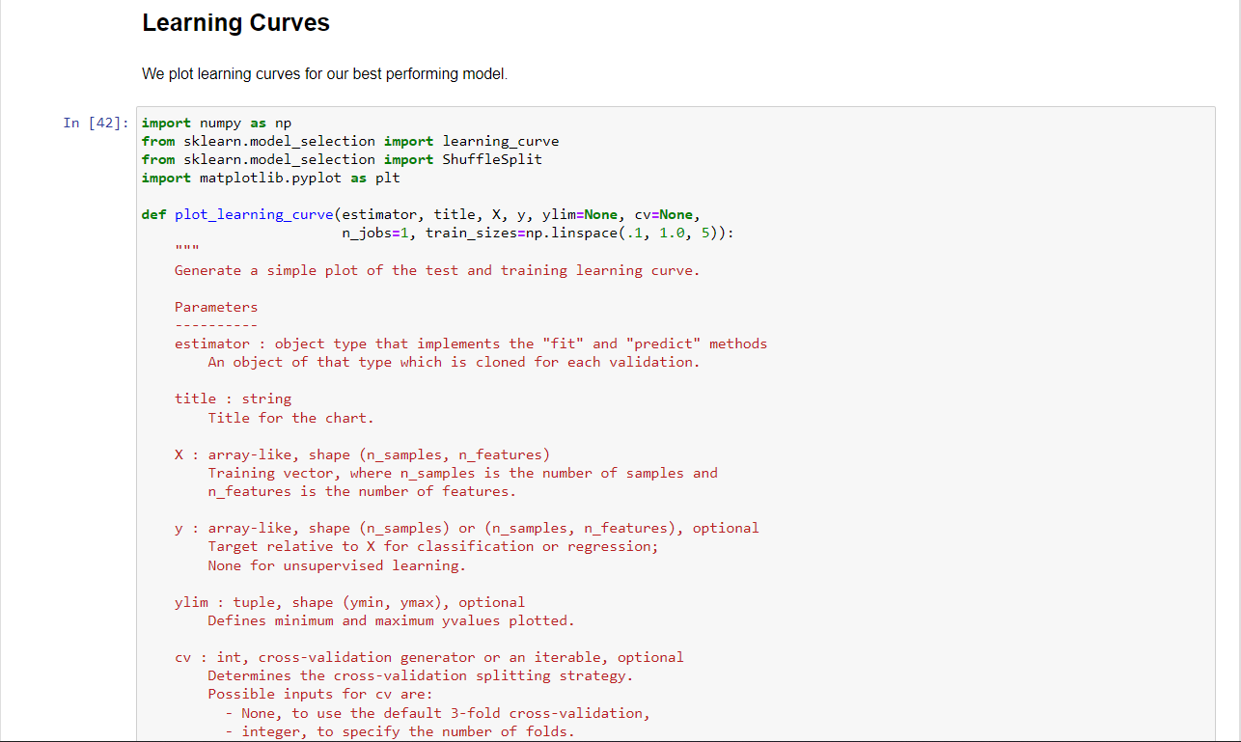

[21] Feature Importance:

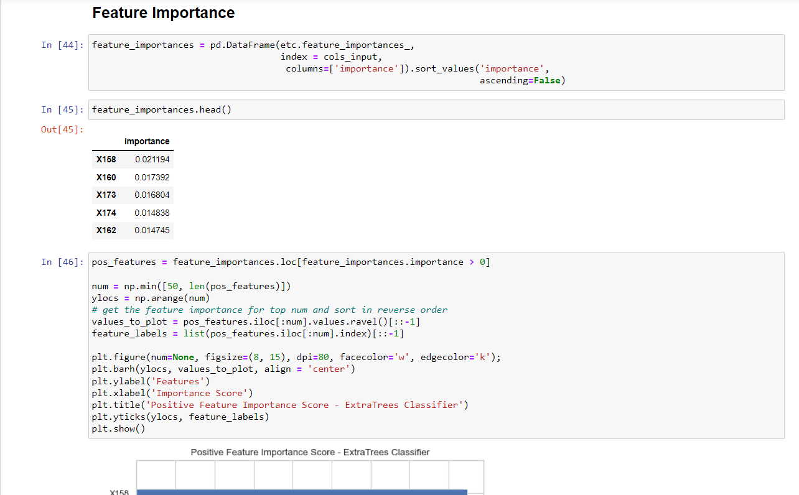

[22] Hyperparameter tuning:

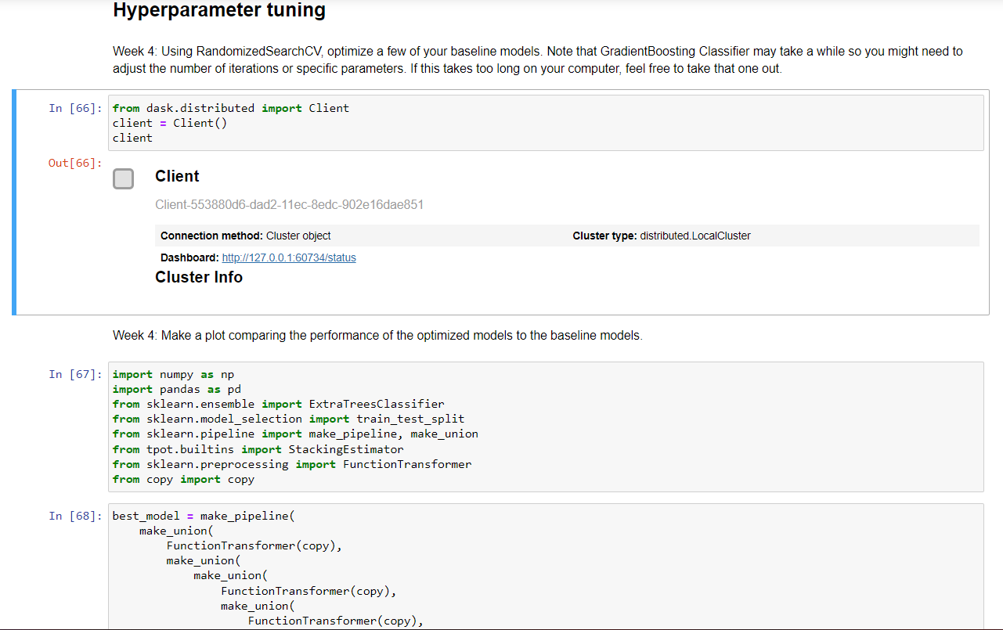

[23] Pick your best model:

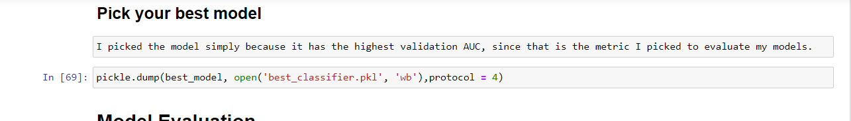

[24] Model Evaluation:

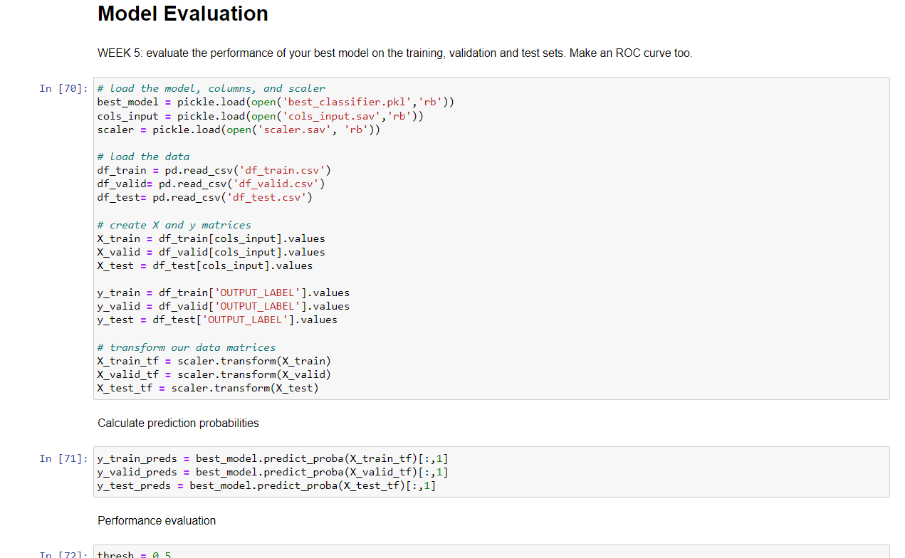

[25] ROC Curve:

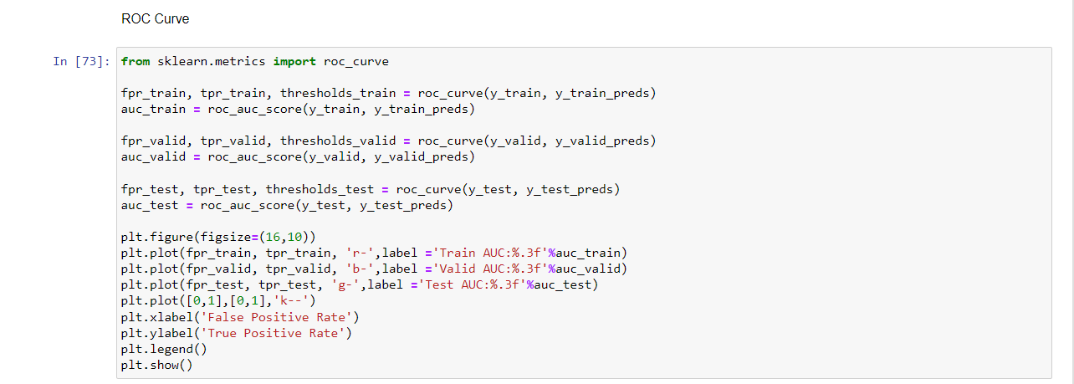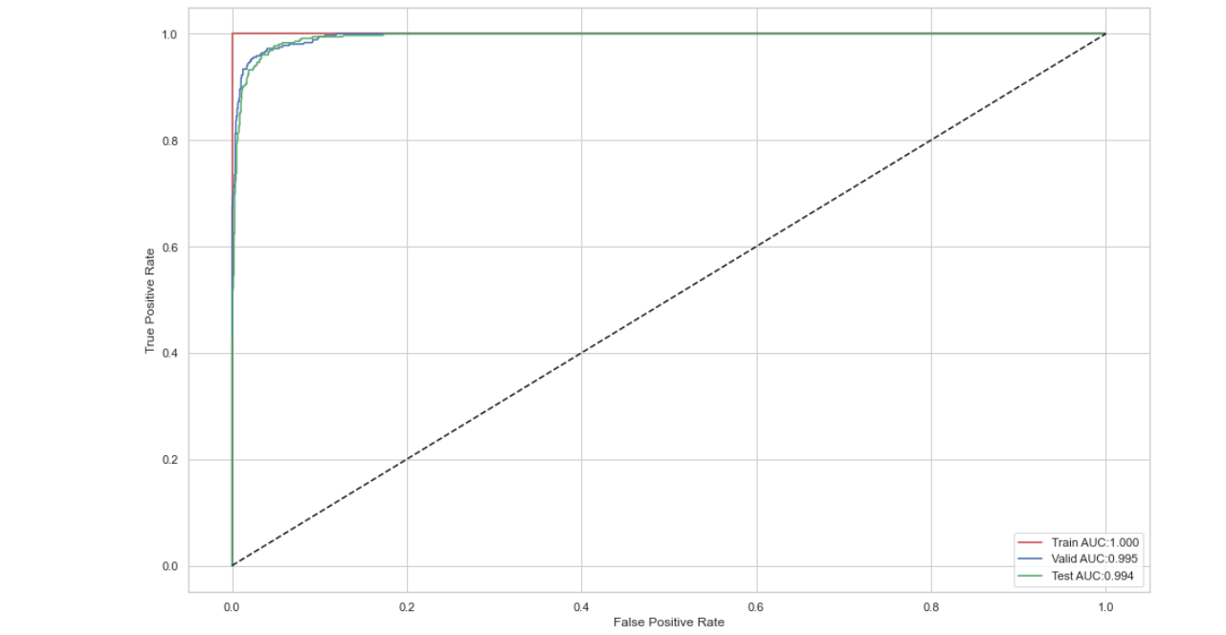

[26]Accuracy:

|  |  |  |  |  |  |  |  |  |  |
| --- | --- | --- | --- | --- | --- | --- | --- | --- | --- |
| model | KNN | Logistic Regression | Stochastic Gradient Descent | Naive Bayes | Decision Tree | Random Forest | Gradient Boosting | Extremely Random Trees |  |
| acc | 0.837 | 0.718 | 0.632 | 0.961 | 0.919 | 0.957 | 0.954 | 0.966 |  |

|  |  |
| --- | --- |
| model | XGBoost |
| acc | 0.967 |

[27] Conclusion:

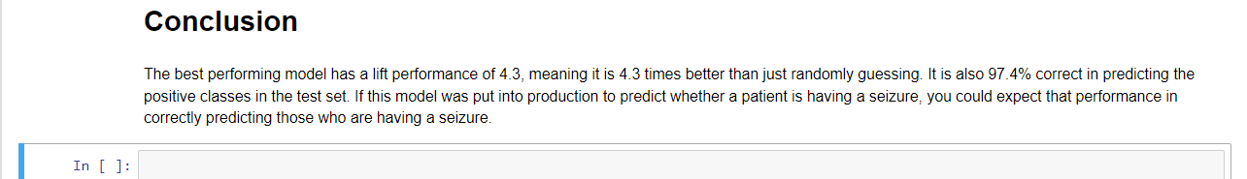

### Name : Ramah hashem madi

### ID no. : 31909303044